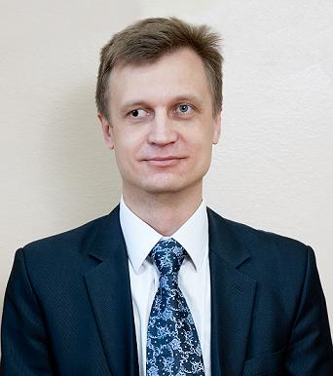

Contact information

|  |  |  |  |  |
| --- | --- | --- | --- | --- |
| Phone: +380993400891  Email: boris.v.skip@gmail.com  Skype: live:.cid.630f45bb76ac6e9e | | | Borys Skip | |
|  | | Position | | |
| **Student of a “Test Automation with Python” course** | | | | |
| Summary of Qualifications | In-class experience with programming on Python, SQL, postgresql, django, css.  Basic knowledge about software development, software testing techniques and software development life cycle.  Strong positive attitude and flexibility to learn new, up-to-date tools and technologies.  Driven and committed to enhance knowledge and skills on Test Automation with Python. | | | |
|  | | | | |
| Skills | **Hard competencies:**  Ability to develop and update scripts written in Python.  Good knowledge on HTML, SQLite, git, css, java script,  django,  Java based - Arduino, Processing, Linux, bash.  Able to install, configure and run simple Python driven code with Selenium webDriver.  Familiar with data mining and analysis, analytics.  Have fundamental understanding of testing process.  **Soft competencies:**  Being an associate professor at university I have strong communication, problem solving, critical observation, conflict resolution, leadership and analytical/quantitative skills.  Being a Vice Dean for Education (2009-2016) good time management skills.  Staying at Jagiellonian University in Krakow as a Postdoctoral fellow in international team I have strong flexibility/adaptability, team work, networking, friendly office culture skills | | | High = █████  █████  ████░  ███░░  ███░░  ███░░  ███░░  ███░░  ███░░  ███░░  github.com/sboris-git |
|  |  | | | |
| Experience / IT related educational practice | **Since 2001 to present**.  Associate Professor of Physical and Environmental Chemistry Department of Chernivtsi National University.  Making and programming do-it-yourself modern data acquisition systems and GUIs for teaching students. Course, I’m teaching, have direct relations to programming, they are: “Chemoinformatics”, “Modelling and Forecasting the State of Environment”. Software are being used - R CRAN, MatLab, Java based Arduino and Processing and from now - Python. Some of them can be revived at https://github.com/sboris-git/ | | | |
|  | **September 1, 2012 – February 28, 2013**  Postdoctoral fellow in international team. Ecotoxicology and Stress Ecology Group Institute of Environmental Sciences Jagiellonian University. Krakow, Poland. Erasmus Mundus European Mobility Programme  Main activities and responsibilities are R CRAN and MatLab modelling of environmental contamination, health effects.  **February 1 – March 22, 2012**  Visiting Scientist at Soil Science and Plant Cultivation (IUNG) - State Research Institute, Puławy, Poland  Deals with databases (SQL) based soil contamination modelling (GRASS GIS) and analysis (R CRAN). Working in international team. | | | |
|  |  | | | |
|  |  | | | |
| Languages | Specify languages and your current level | | | |
| Ukrainian (Mother tongue) | | | |
| English (B2 certified at Jagiellonian University/Intermediate+) | | | |
|  |  | | | |
| Education | [Doctor of Philosophy (PhD) in Chemistry]  [2001] | | | |
| [Master of Science (MSc) in Chemistry]  [1997] | | | |
|  |  |  |  |

|  |  |  |
| --- | --- | --- |
| Additional education (courses, trainings) | [Python Core at SoftServe IT Academia]  [2019]  [Python for Beginners at Prometheus.org.ua]  [2019]  [English at Jagiellonian University, Kracow, Poland]  [2014] | |
|  | | |
| Hobbies | Do it yourself electronics (Arduino based).  Artificial Intelligence.  Lifelong learning.  Volleyball.  Traveling. |  |